Safe Work Method Statement
Organisation:
Task: Preparing meals
Task objective: Cooked food
Risks:  - Slip/trip  - Prolonged standing  - Burns/scalds  - Lacerations  - Dermatitis  - Repetitive upper limb movements  - Manual handling  - Chemical contact  - Fire  - Electric shock |  |  | 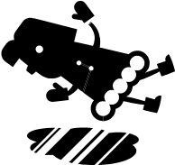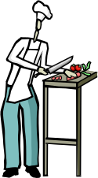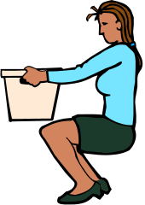
Tools and PPE:  - Microwave  - Mixer  - Griller  - Oven  - Small kitchen appliances  - Dishwasher  - Oven mitts  - Gloves and apron  - Non-slip shoes |  |  | 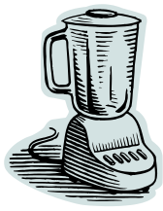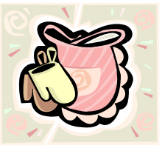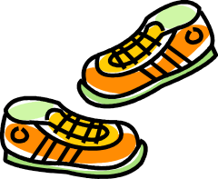
Training and instruction:  - Manual handling  - Food safety  - Chemical safety  - Task and equipment specific |  |  | 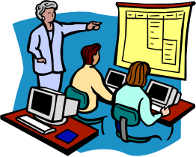
Steps
Prior to procedure:  - Obtain items from coolroom or storeroom  - Obtain correctly coloured chopping boards  - Prepare vegetables by chopping or peeling  - Ensure knives etc are sharp and suited to task  - Prepare meat/fish by washing, chopping etc  - Prepare sauces by measuring ingredients together |  |  | 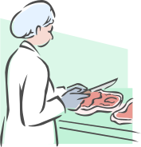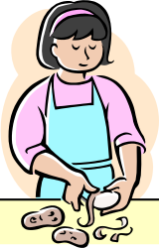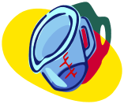
During procedure:  - Wash hands whenever changing tasks etc.  - Place vegetables in pot on stove top and pour in water and heat or place on tray and place in oven  - Place meat in pots or trays and place on stove top or in oven  - Mix sauces and stir as required  - Slice roast meats using meat slicer or carving knife  - Serve up meals onto individual plates and place on trays or table |  |  | 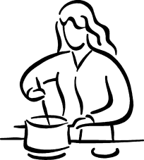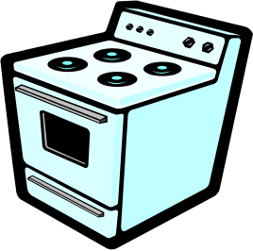  
Post procedure:  - Place used utensils etc in sink or dishwasher and wash  - Place knives etc back on rack  - Clean down counter top and floor wearing gloves |  |  | 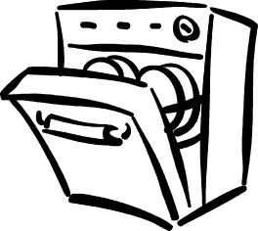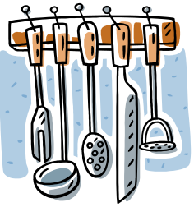
Precautions:
- Provide non-irritant hand soap and hand lotion
- Ensure floor surfaces suitable and appropriate footwear
- Plan pedestrian traffic routes and ensure good housekeeping
- Ensure adequate lighting and ventilation
- Store heavy items close to where they will be used
- Use trolleys whenever possible
- Order goods in manageable quantities
- Use good manual handling techniques
- Display weights on heavy or bulky items or equipment
- Keep fingers away from knife edge and cut away from body
- Use appropriate equipment for the task
- Ensure adequate space and no distractions
- Ensure guards are on any equipment
- Use oven mitts etc for handling hot objects
- Only fill mop bucket half full and place out wet floor signs prior to mopping
- Ensure MSDS available for chemicals and gloves worn
- Use automatic dispensers for chemicals
Read by: | Signed: | Date:

Specific Safe Work Practices

Hobart Mixer:  - Ensure all parts including guards are secure before powering on machine  - When power is on never place hands inside bowl  - Do not leave unattended with power on  - Lift and carry full bowl with two hands  - Ensure power if off before washing up | 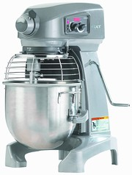
Slicer:  - Only to be used by trained staff  - Use in isolated area demarked by non slip mat  - Ensure all parts are secure and all material at hand before powering on  - Always use pusher to hold meat  - Never leave machine unattended with power on  - Ensure power is off before washing up  - Beware of knife blades whilst washing | 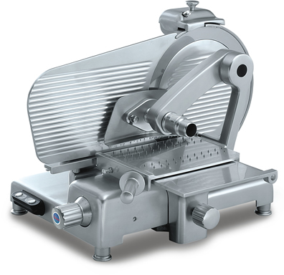
Urns:  - Always place hot urns in same place  - Cold drinks and refreshments are not to be served on the same table as a hot urn  - Place “Caution Hot” sign next to urn  - Full urns are only to be transported on a trolley and never when hot  - If carrying an urn ensure it is empty  - Use a heatproof jug to fill or empty urn so that it is not heavy  - Do not use an urn if there is no sinks on same floor – use a kettle instead | 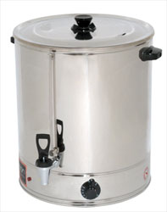
Ovens and Cooktops:  - Ensure ovens have two step opening process  - Before opening oven ensure no one is standing in front of opening  - Use oven gloves as appropriate  - Ensure handles on pots are not hanging over edge  - Use a jug or similar to poor liquid into large pots and ladle to remove liquid rather than lifting of pots | 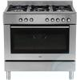
Microwave Oven:  - Do not place metal objects in microwave  - Only use microwave safe containers in microwave  - Do not place empty plates etc. in microwave  - When opening microwave allow built up steam to escape before removing contents (use potholder).  - Beware container may be hot or container may feel cool and contents are extremely hot.  - Always clean spills and splashes from inside of microwave.  - If boiling liquids in microwave, be careful when stirring the contents as it may bubble up all of a sudden and burn you. | 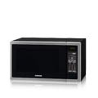
Serving Hot Food:  - All hot food containers should be placed on cloths or cutting boards on the bench  - All hot food containers should be placed toward the centre of the bench not on the edge  - Use separate utensils for different food stuffs  - Do not touch food with your hands  - Where possible move the plates along the bench to the next item rather than holding them.  - Do not attempt to carry more than two laden plates at a time  - Wipe down bench before and after serving. | 

